**Setter methods**

Setter methods are method used to set (modify) the components of date object.

These methods are:

1. **setDate();**

This method is used to set day number within the month (1:31) instead of the current day number.

**Example 1:**

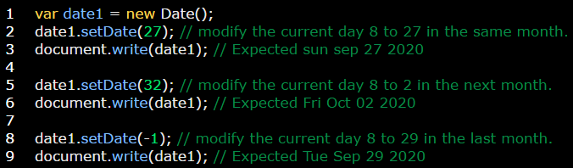

1. **getMonth();**

This method is used to set month number within the year (0:11) instead of the current month number.

Number of Months is:

|  |  |
| --- | --- |
| **Day** | **Number** |
| January | 0 |
| February | 1 |
| March | 2 |
| April | 3 |
| May | 4 |
| June | 5 |
| July | 6 |
| August | 7 |
| September | 8 |
| October | 9 |
| November | 10 |
| December | 11 |

**Example 1:**

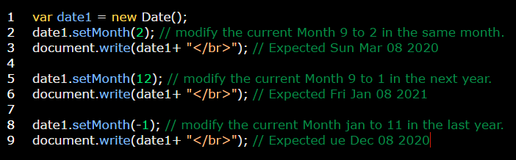

**Example 2:** if you need to return Month name instead of Month number use switch method**.**

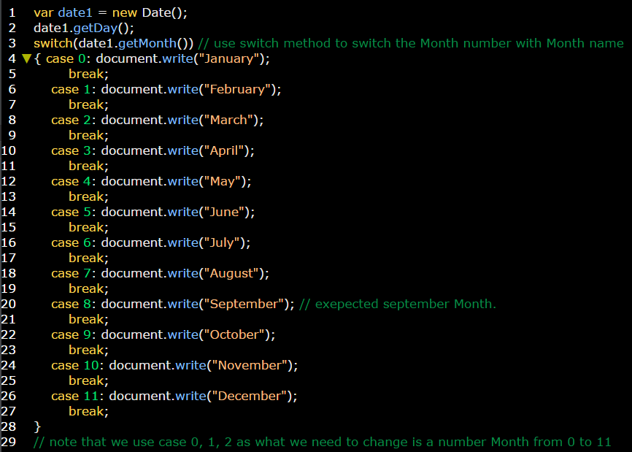

1. **getFullYear();**

This method is used to set year instead of the current year.

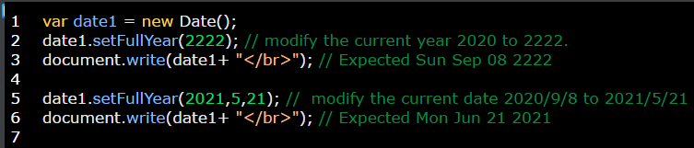

1. **getHours();**

This method is used to set a specific day’s hour (0:23) instead of the current day’s hour.

**Example 1:**

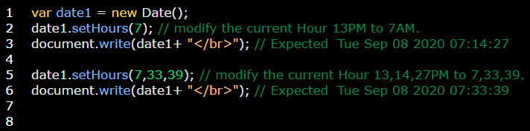

1. **getMinutes();**

This method is used to set a specific hour’s minute (0:59) instead of the current hour’s minute.

**Example 1:**

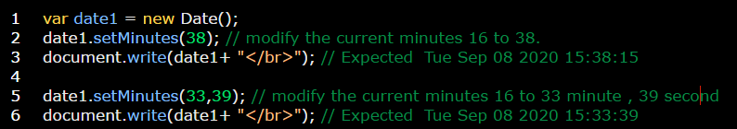

1. **getSeconds();**

This method is used to set a specific minute’s seconds (0:59) instead of the current minute’s seconds.

**Example 1:**

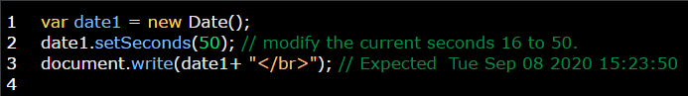

1. **getMilliseconds();**

This method is used to set a specific second’s milliseconds (0:999) instead of the current second’s milliseconds.

**Note:** 1s = 1000ms

**Example 1:**

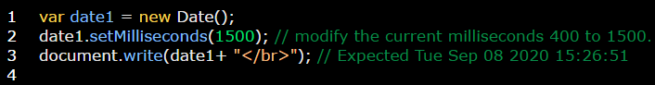

**UTC:** is used with all above set methods to get the global / universal time.

**Example:**

